SOFTWARE ARCHITECTURE OF STUDENT ATTENDANCE TRACKING SYSTEM

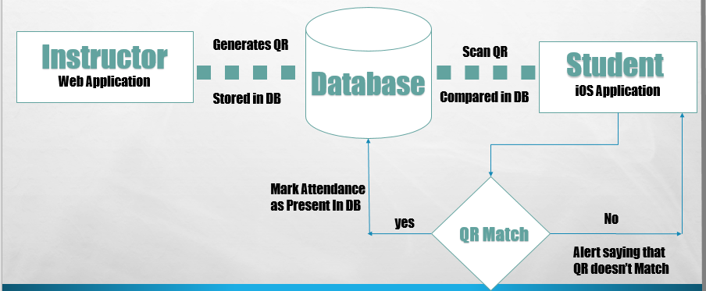

**Figure1: System Architecture of Student Attendance Tracker**

**Module 1: Instructors application** is the Web application generating QR using a unique code, which gets stored in the database and displaying it to the students, so that students can scan the QR code to mark their attendance.

**Module 2: Student application** is the iOS application, which scans the QR, checks if the student is registered for the course from the database and marks attendance if the scanned QR code matches the unique string in the database.

**Intermediate System: The database** holds Student Information, Instructor Information, Course information, Attendance data of each student and QR data - unique string that is used in generating the QR code.

# UML Diagram of the complete System

This diagram represents the interactions between the objects of the system. The objects here are the unrelated actions that are being performed by the individual system. The below diagram represents the dynamic behavior of the system. The communication between the subsystems, i.e. the mobile application and the web application happen via the database. The database interconnects the subsystems by storing data and modifying data while keeping the data integrity in check.

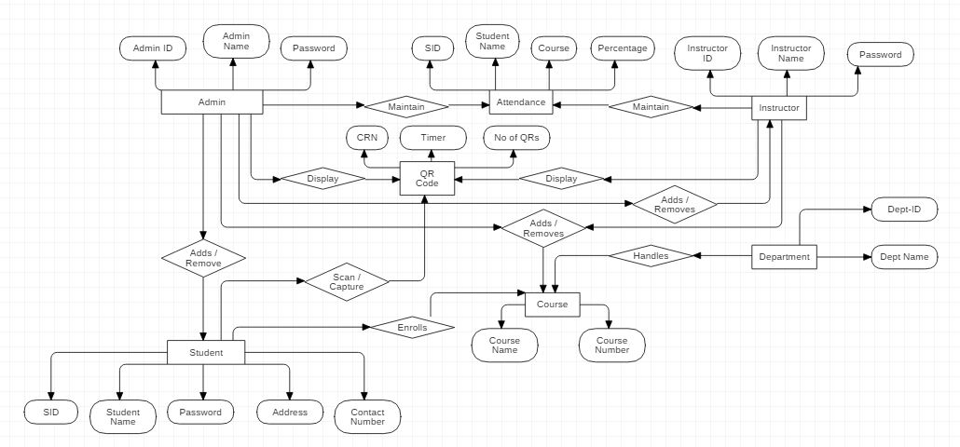

**Fig 2: UML diagram of the complete System.**